## DAYANANDA SAGAR COLLEGE OF ENGINEERING

**(An Autonomous Institute affiliated to VTU, Belagavi - 590018) Shavige Malleshwara Hills Bangaluru-560078, Kumaraswamy Layout**

**Accredited by National Assessment & Accreditation Council (NAAC) with ‘A’ grade Accredited by National Board of Accreditation (NBA)**



**A Miniproject Report On**

##### “AI BASED SNAKE GAME ANALYSIS AND SIMULATION USING NEURAL NETWORKS”

**Bachelor of Engineering In**

**Electronics & Instrumentation Engineering**

Submitted by

**SUHAIL AHMAD A S 1DS17EI035**

***Under the guidance of***

**DR.GOPALAIAH**

###### Dept. of E&IE DSCE, Bangalore

**DEPARTMENT OF ELECTRONICS & INSTRUMENTATION ENGINEERING**

**(Accredited by NBA)**

###### DAYANANDA SAGAR COLLEGE OF ENGINEERING

**Affiliated to Visvesvaraya Technological University Belagavi-590018**

**2018-2019**

**DAYANANDA SAGAR COLLEGE OF ENGINEERING**

**(An Autonomous Institute affiliated to VTU, Belagavi - 590018) Shavige Malleshwara Hills Bangaluru-560078, Kumaraswamy Layout**

**Accredited by National Assessment & Accreditation Council (NAAC) with ‘A’ grade Accredited by National Board of Accreditation (NBA)**

**CERTIFICATE**



2018-19

This is to Certify that the Miniproject entitled “**AI BASED SNAKE GAME ANALYSIS AND SIMULATION USING NEURAL NETWORKS**” is a bonafide work carried out by PRAYUKTHA (1DS17EI024) in partial fulfillment for the award of degree of **Bachelor of Engineering** in **Electronics and Instrumentation Engineering,** of **DAYANANDA SAGAR COLLEGE OF ENGINEERING**, An Autonomous Institute affiliated to VTU, Belagavi during the year **2018-2019**. It is certified that all the corrections/suggestions indicated for the internal assessment have been incorporated in the report deposited in the departmental library. The Miniproject report has been approved as it satisfies the academic requirements in respect to the project work prescribed for the Bachelor of Engineering Degree.

|  |  |  |
| --- | --- | --- |
| **Internal Guide** | **Head of Department** | **Principal** |
| DR.GOPALAIAH | Dr. J.S. RAJASHEKAR | Dr. C P S Prakash Dept. |
| E&IE, DSCE | Dept. E&IE, DSCE | DSCE, Bangalore |
| External Viva Name of examiners 1. |  | Signature with date |
| 2. |  |  |

**ACKNOWLEDGEMENT**

The success and final outcome of this Miniproject work required the guidance and the assistance of many people. We would like to add a few words of appreciation to the people who have been a part of this right from its inspection. Without their support, patience and guidance, this task would not have been completed. It is to them we owe our greatest gratitude.

We take this opportunity to express our deep regards to **Dr. C.P.S PRAKASH**, Principal, Dayananda Sagar College of Engineering for providing an opportunity to do this Miniproject as a part of our curriculum in partial fulfillment of the degree course.

We take this opportunity to express a deep sense of gratitude to **Dr. J.S RAJASHEKAR** Professor and Head, Department of Electronics and Instrumentation Engineering for his cordial support and guidance.

I extend my immense pleasure in thanking **Dr. GOPALAIAH** Assistant Professor and coordinator, Department of Electronics and Instrumentation Engineering, for providing me invaluable co ordinance for the project.

We owe our profound gratitude to our project Guide **DR.GOPALAIAH** Department of Electronics and Instrumentation Engineering, Dayananda Sagar College of Engineering for her constant support throughout the period of our project.

We also feel heartiest sense of obligation to all the faculty members for their timely support and their cooperation till the completion of our project. We also extend our heartiest thanks to all the supporting staff who directly or indirectly helped us bringing out this project satisfactorily in the specified duration.

PRAYUKTHA (1DS17EI024)

## DAYANANDA SAGAR COLLEGE OF ENGINEERING

**(An Autonomous Institute affiliated to VTU, Belagavi - 590018) ShavigeMalleshwara Hills Bangaluru-560078, Kumaraswamy Layout**

**Accredited by National Assessment & Accreditation Council (NAAC) with ‘A’ grade Accredited by National Board of Accreditation (NBA)**



2018-2019

### DECLARATION

I, **SUHAIL AHMAD A S (1DS17EI035)** declare that the Miniproject entitled “**AI BASED SNAKE GAME ANALYSIS AND SIMULATION USING NEURAL NETWORKS**” has been successfully carried out under the guidance of **DR. GOPALAIAH**, Department of Electronics and Instrumentation Engineering, Dayananda Sagar College of Engineering in partial fulfillment of the requirement of the degree **Bachelor of Engineering** in **Electronics and Instrumentation Engineering** of **VISVESVARAYA TECHNOLOGICAL UNIVERSITY**, Belagavi. This Miniproject is not submitted by us to any other universities or institution for the award of any other degree.

Place: Bangalore

###### SUHAIL AHMAD A S

(1DS17EI035)

# Introduction

#### What is a Neural Network?

The simplest definition of a neural network, more properly referred to as an 'artificial' neural network (ANN), is provided by the inventor of one of the first neurocomputers, Dr. Robert Hecht-Nielsen. He defines a neural network as: "...a computing system made up of a number of simple, highly interconnected processing elements, which process information by their dynamic state response to external inputs. ANNs are processing devices (algorithms or actual hardware) that are loosely modeled after the neuronal structure of the mamalian cerebral cortex but on much smaller scales. A large ANN might have hundreds or thousands of processor units, whereas a mamalian brain has billions of neurons with a corresponding increase in magnitude of their overall interaction and emergent behavior. Although ANN researchers are generally not concerned with whether their networks accurately resemble biological systems, some have. For example, researchers have accurately simulated the function of the retina and modeled the eye rather well Although the mathematics involved with neural networking is not a trivial matter, a user can rather easily gain at least an operational understanding of their structure and function.

**The Basic of Neural Network:** Neural neworks are typically organized in layers. Layers are made up of a number of interconnected 'nodes' which contain an 'activation function'. Patterns are presented to the network via the 'input layer', which communicates to one or more 'hidden layers' where the actual processing is done via a system of weighted 'connections'. The hidden layers then link to an 'output layer' where the answer is output as shown in the graphic below

#### How do Neural Network Differ From Convolutional Computing?

To better understand artificial neural computing it is important to know first how a conventional 'serial' computer and it's software process information. A serial computer has a central processor that can address an array of memory locations where data and instructions are stored. Computations are made by the processor. reading an instruction as well as any data the instruction requires from memory addresses, the instruction is then executed and the results are saved in a specified memory location as required. In a serial system (and a standard parallel one as well) the computational steps are deterministic, sequential and logical, and the state of a given variable can be tracked from one operation to another.

In comparison, ANNs are not sequential or necessarily deterministic. There are no complex central processors, rather there are many simple ones which generally do nothing more than take the weighted sum of their inputs from other processors. ANNs do not execute programed instructions; they respond in parallel (either simulated or actual) to the pattern of inputs presented to it. There are also no separate memory addresses for storing data. Instead, information is contained in the overall activation 'state' of the network. 'Knowledge' is thus represented by the network itself, which is quite literally more than the sum of its

individual components.

#### Objective of the Project:

The main objective of the project is to implement the neural in real time. And train the model to improve itself for the better result in the future. And learn the importance of the concept which would to improve the technology.

#### Processing Software:

Software prototyping and data visualization are two of the most important areas for Processing developers. Research labs inside technology companies like Google and Intel have used Processing for prototyping new interfaces and services. Companies including General Electric, Nokia, and Yahoo! have used Processing to visualize their internal data. For example, the New York Times Company R&D Lab used Processing to visualize the way their news stories travel through social media. The NSF and NOAA supported research

exploring phytoplankton and zooplankton diversity that was realized at the University of Washington as a dynamic ecology simulation. Researchers at the Texas Advanced Computer Center at UT Austin have used

Processing to display large data visualizations across a grid of screens in the service of humanities research.

**Software Link:** https://processing.org/download/

###### SNAKE AI Neural Network:

Each snake contains a neural network. The neural network has an input layer of 24 neurons, 2 hidden layers of 16 neurons, and one output layer of 4 neurons. Note: Network can now be customized with the number of hidden layers as well as the number of neurons in the hidden layers.

Snake has simple rules:

1. The world is a grid.
2. The snake can only travel orthogonally along this grid.
3. This world has a border that kills the snake on contact.
4. The snake cannot stop moving.
5. If the snake runs into itself, it dies.
6. Every time the snake eats, it grows longer.
7. The goal is to grow as long as possible.

###### Vision

The snake can see in 8 directions. In each of these directions the snake looks for 3 things:

* Distance to food
* Distance to its own body
* Distance to a wall

3 x 8 directions = 24 inputs. The 4 outputs are simply the directions the snake can move.

###### Fig: Showing the 8 Direction Measurement form the head of the snake

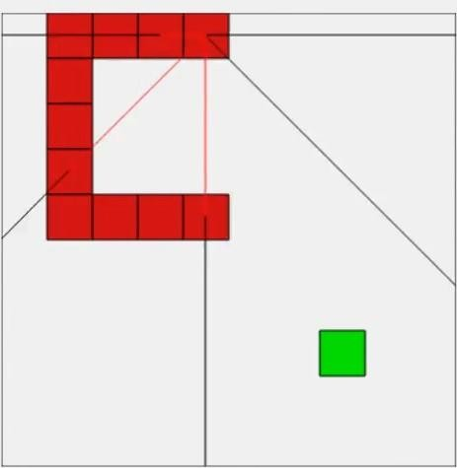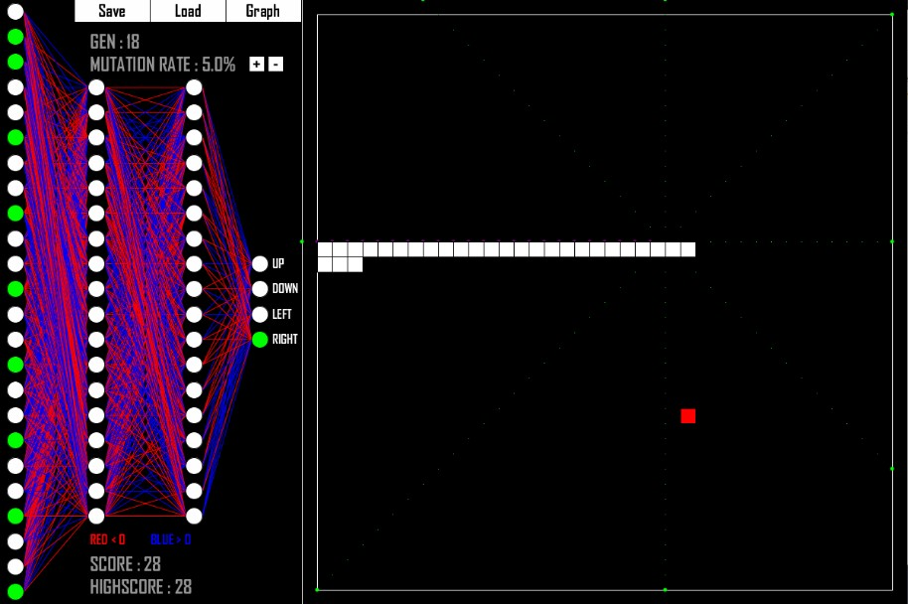

**Natural Selection:**

**Evolution:**

Each generation a population of 2000 snakes is created. For the first generation, all of the neural nets in each of the snakes are initialized randomly. Once the entire population is dead, a fitness score is calculated for each of the snakes. Using these fitness scores, some of the best snakes are selected to reproduce. In reproduction two snakes are selected and the neural nets of each are crossed and then the resulting child is mutated. This is repeated to create a new population of 2000 new snakes.

#### Fitness:

A snakes fitness is dependant on how long the snake stays alive as well as its score. However they are not equally important, having a higher score is rewarded more than a snake who simply stays alive. There is the possibility however that a snake may evolve a strategy where it loops in a certain pattern and never dies. Even though having a high score is prioritized more, if a snake can stay alive forever then that is a clear problem. To avoid this each snake is giving 200 starting moves at the beginning of its life. Every time it eats a piece of food it gains 100 more moves, with a maximum of 500 moves. This means that snakes who evolve to go in loops will eventually die and snakes who go for the food will not only have a higher score, but stay alive longer.

#### Crossover & Mutation[10% rate]:

When two snakes are selected for reproduction, what happens is that the snakes brains are crossed with each other. What this means is that part of one parents brain is mixed with part of the second parents and the resulting brain is assigned to the child. After the crossover the brain is also mutated according to a mutation rate. The mutation rate determines how much of the brain will be randomly altered.

#### What is Data Collection?

**Data Collection:**

As a society, we’re **generating data at an unprecedented rate** (see **big data**). These data can be numeric (temperature, loan amount, customer retention rate), categorical (gender, color, highest degree earned), or even free text (think doctor’s notes or opinion surveys). Data collection is the process of gathering and measuring information from countless different sources. In order to use the data we collect to develop practical **artificial intelligence (AI)** and **machine learning** solutions, it must be collected and stored in a way that makes sense for the business problem at hand.

#### Why is Data Collection Important?

Collecting data allows you to capture a record of past events so that we can use data analysis to find recurring patterns. From those patterns, you build predictive **models** using machine learning **algorithms** that look for trends and predict future changes. Predictive models are only as good as the data from which they are built, so good data collection practices are crucial to developing high-performing models. The data need to be error-free (garbage in, garbage out) and contain relevant information for the task at hand. For example, a loan default model would not benefit from tiger population sizes but could benefit from gas prices over time.

#### Graphing:

The graph represents the score of the best snake from each generations. In some generations the graph may dip bellow the previous, this is because even though the score may have been worse, some trait allowed the snake to live longer and gain a higher overall fitness.

##### Fig: Data Interpretation of the Model during the training

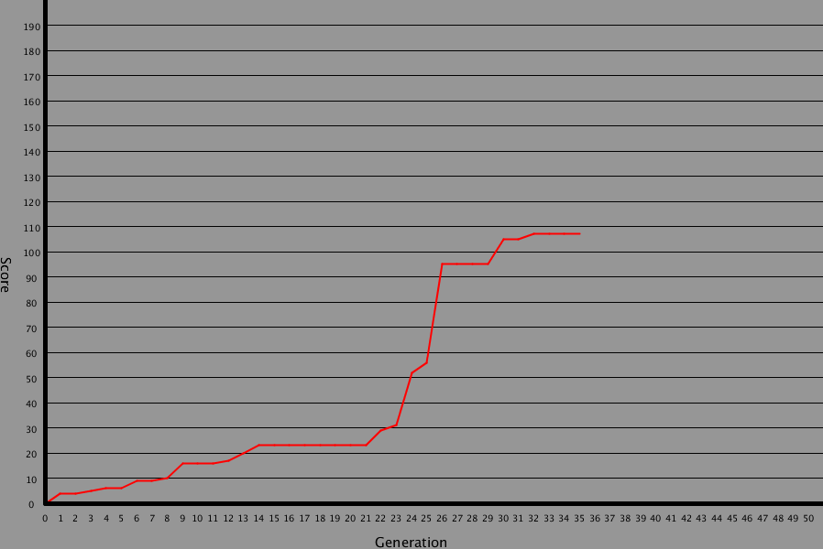

**Save & Load**

Models can be saved and loaded in order to test a model in new situations. The weights for each connection are saved in a CSV file. The evolution graph is also saved in order to view the evolution progress of the model.

**Choosing a Method**

There are many methods, algorithms, and techniques that could be used to solve Snake. Some of these could fall under the umbrella term of AI. Let us focus on a single method: *genetic random mutation of a neural network.*

This is because:

1. No dataset of high scoring Snake play throughs to use to train a neural network by example.
2. Personal interest in seeing if it’s possible to evolve logic that can play Snake through only random mutations.

**What is a Genetic Algorithm?**

Instead of picking a network type and then slowly training it based on example Snake gameplay, let us create a scenario for one to evolve on its own. All changes to the neural nets will be random — not through direct feedback of playing the game move-by-move. Overtime, small random changes to the neural networks should lead to a fully functioning AI as the top performers in each generation survive to breed the next.

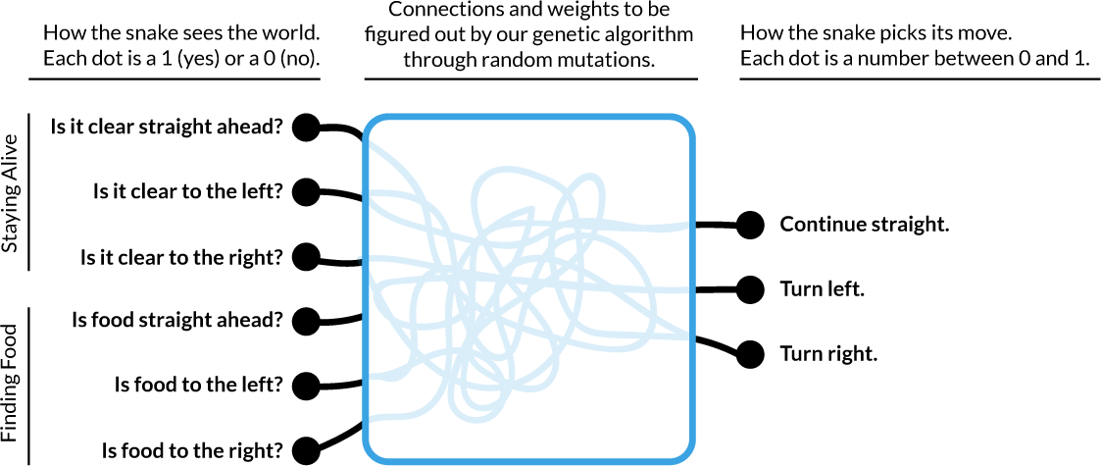

Each piece of information given to and received from a neural network needs to be between zero and one. To satisfy this, we’ve broken up all of the input data into *yes or no* questions about each relative direction. It’s important to note that the neural net has no information about what these numbers mean or even that they are in two sets of three. To the AI, it’s just a list of 6 numbers.

Our output data is broken out in a similar way. We are asking our neural net to give us three numbers. We are simply going to pick the highest number and use that to move the snake in the direction described above. The neural net doesn’t start off knowing what these numbers are for — or how they will be used.

We are going to generate many versions of the neural net and allow each to have an attempt at moving the snake around. Those that perform best have made a connection between some aspect of the input and output data that keeps it alive. Over time we are going to continue to tweak those that got the highest scores — and eventually we’ll have an AI that plays Snake.

RESULT: We have designed a sophisticated snake ai model to score 150 points at 200 generations.

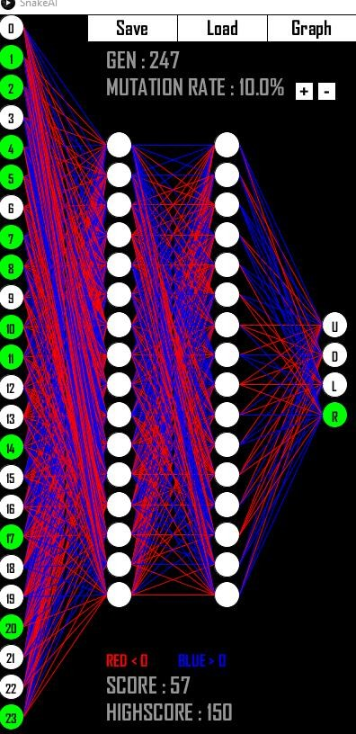

Conclusion and Future Work

We can all agree that Artificial Intelligence has changed our lives for the better. It has completely revolutionized

the technology landscape that millions of people reap benefit from. That said, there are so many problems that exist in this world that still need to be solved. It is upto the current & future generation of engineers to use their skills and make a difference. For us to make the difference, we need all the education we can get from the universities we study in. Most colleges teach the theory well, but fail to focus on the practical aspects. In reality, you can’t learn with just theory. You need to implement what you learn to truly understand the concepts. That’s why a tool like this would be the perfect learning tool for students learning Machine Learning or Artificial Intelligence for the first time. This tool with its intuitive features will enable the student to take interest in the subject and solve the problem. Video games have been used as a learning tool for a long time now. It is proven that; video games help increase interest in the learning process. After all, learning isn’t learning if it is not enjoyed. Hopefully, this tool can make Intelligence models really well and enable them to make a huge impact in the industry*.* That said, there are still many limitations in the current iteration of the project.

APPLICATIONS:

Convolutional Neural networks are used in image biopsy analysis of bone deformation These concepts are used in ROBBY TECHNOLOGIES which is used for delivering groceries and essentials to home. These machines are trained by a mountain of data with many generations.

CNN was used in Georgia Tech’s prosthetic arm to learn human muscular movement to move fingers.

AIVA(Artificially Intelligent Virtual Artist) Technologies has developed an AI which can even compose music using neural networks. The AI learns by pattern of many musicians and composes its own music.

NCSA at Illinois uses CNN to do galaxy classification in order to find out the origin of our universe.

VOICEITT is an AI developed software. Voiceitt provides a new dimension of independence and quality of life for people with speech and motor disabilities, and a useful tool for those who care for and about them.

Viz LVO uses artificial intelligence to automatically identify suspected large vessel occlusion strokes on CT angiogram imaging in your network and to alert your on-call stroke team within minutes.

REFERENCES

* GITHUB.
* “Genetic algorithms in search, optimization, and machine learning” – DAVID E GOLDBERG.
* towardsdatascience.com